|  |
| --- |
| Circle Language Spec: Execution Control |

## Select Case (exact value) in a Diagram

The concept of the Select Case (exact value) statement is already covered by the article *Select Case (exact value)*. This article only explains its expression in a diagram.

Below is an example of the diagrammatic expression of a Select Case statement for comparing exact values.

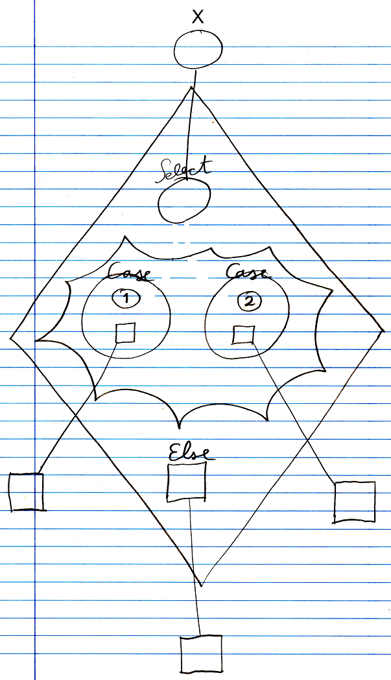

The diamond is a call to the Select Case command. The circle inside the diamond has the title Select. It points to an object outside the command call. This will be the variable to which several values will be compared. In the middle of the diamond there is a nonagon, that represents the cases: values to which the variable will be compared. The nonagon can contain any number of cases. Each circle inside a nonagon is a Case. Each case defines a value, and the command to call, if the variable matches the value. In this example, there are two Cases. One Case has the value 1 and the other Case has the value 2. Each Case has a command associated to it. Those command references are pointing to clauses defined outside the diamond. At the bottom of the diamond there is also a command reference called Else. It points to a clause defined outside the diamond. The command pointed to will be called if the variable matches none of the values defined in the Cases. If the Else clause is not used, it can be left out of the call and then it will not be shown in the diagram.

The values for the cases were entered litterly into the case. A value for a case can also be defined as a pointer to an object that holds the value. The same way, the variable could also have gotten an exact value, and not be a pointer to an object outside the diamond. The command references did not have to point to something defined outside of the diamond either. The commands could have been defined right inside the diamond, but it often looks more intuitive to define clauses outside the diamond.

The *definition* of the Select Case execution control commands is part of a system module of execution control commands. The public elements of the definition look like this:

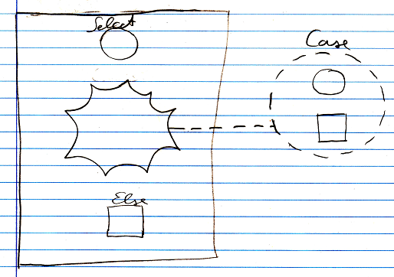

Nothing is filled in yet as the Select or Else, and there are no Cases defined, but a *class* for a Case *is* defined.

There is another, separate definition of the Select Case command for comparison of exact values, that is the same as the other Select Case command definition, except that it does not have an Else clause in it.

See also: *Select Case (exact value)*

*Author & Copyright: Jan-Joost van Zon Date: June 7, 2008 – June 7, 2008 Location: Oosterhout, The Netherlands Status: Finished*